Easy part:
- Ronny and Donny at point X on one side of a river, (40ft wide and with a current flowing at 3 ft/sec), simultaneously spot Bonny sunbathing at point Y directly opposite. They dive in at the same instant and swim across. Both swim at 5 ft/sec relative to water. Ronny directs himself such that his net motion is in the direction XY, while Donny always has his body perpendicular to the current, and consequently lands at point Z. He then runs to Bonny with a speed of 16ft/sec. Who reaches Bonny first and by what time interval?
A) D by 1 sec B) D by half sec C) same D) R by half sec E) R by 1 sec

- We must use up out stock of massless ropes and frictionless pulleys! Deduce the acceleration of the 3 kg mass. Take + to indicate the upwards direction. The arrow is for those who don’t know which way is up!(answers in m/sec2).
A) -15 B) -6.7 C) -1.4 D) 0.91 E) 10
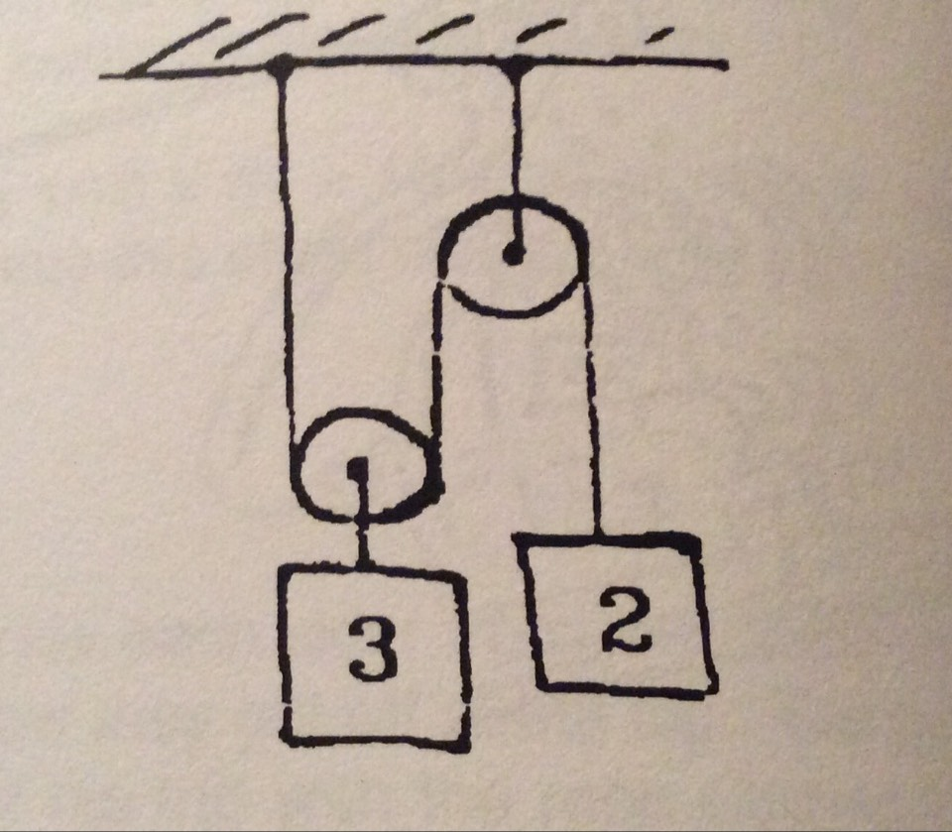

- The Easter Bunny runs along a straight and narrow path with a constant speed of 25 m/s . He passes a sleeping tortoise, who immediately starts to chase him with a constant acceleration of 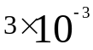 m/s2. How long does it take the tortoise to catch the Bunny?(Answers in hours)
A) 2.3 B) 4.6 C) 6.9 D) 9.2 E) he can never catch up

Medium:
- A U-tube has vertical limbs about 50 cm long with a cross-sectional area of 1.5 cm2. It is half filled with water that has a density of 1000kg/m3. Coal-oil, whose density is 800kg/m3, is carefully poured into one side so that it floats on top of the water. The surface of the water on the other side rises by 5 cm. How much coal-oil has been added?(Answers in cm3)
A) 5 B) 7.5 C) 9.4 D) 12.5 E) 18.8

- An Australian bushman hunts kangaroo with the following weapon. A heavy rock is tied to one end of a light vine of length 2 m. He holds the other end above his head, at a point 2 m . He holds the other end above his head, at a point 2 m above ground level, and swings the rock in a horizontal circle, as sketched. The cunning kangaroo has observed that the vine always breaks when the angle θ(between vine and vertical) reaches 60°. At what minimum distance from the hunter can the kangaroo stand with no danger of a direct hit?(A really cunning kangaroo might crouch inside the circular path -- safe from the rock. We rule hm out of order.) (Answers in meters.)
A) 2.5 B) 3.1 C) 4.2 D) 5.4 E) 10

- Two wooden blocks A and B, connected by an unstretched spring with a spring constant k = 950 N/m, are initially at rest on a frictionless surface. A bullet of mass 50 g moving horizontally with a inital speed of V0 = 120 m/s hits Block A and becomes embedded in it. The embedding takes place within a very short time. The mass of Block A is 1.2 kg and that of Block B is 2 kg. Calculate the maximum compression of the spring.

Hard:
7. As shown in fig, m = 5kg, θ= 30°, μ= 0.75, what is the minimum magnitude of F so we can move the block?
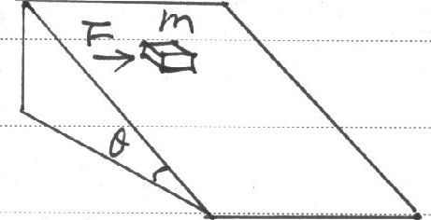

8. A small ball is launched with a velocity of 10√2 m/s at ɑ = 45°. After 0.5 seconds, the ball has a elastic collision with a wall(far more heavier than the ball) moving at a constant velocity of 2m/s. Find out the distance between the point where the ball hits the ground and point A.
